# A JOB LISTING WEB APPLICATION FOR PEOPLE SEEKING JOBS

By

Jared Onguny

131539

An Information System Project proposal submitted to Strathmore Institute in partial fulfillment of the requirements for the award of the Diploma in Business Information Technology

Strathmore Institute  
Strathmore University  
Nairobi, Kenya

12/05/2022

# Declaration

I Jared Onguny declare that this work has not been previously submitted and approved for the award of a Diploma Certificate by this or any other University. To the best of my knowledge and belief, the proposal contains no material previously published or written by another person except where due reference is made in the proposal itself.

Student’s signature:

………………………………….…………. [*Signature*]

………………………………….…………. [*Date*]

**Approval**

The Information System Project proposal of Jared Onguny was reviewed and approved *(for examination)* by:

Supervisor’s signature:

………………………………….………….. [*Signature*]

………………………………….………….. [*Date*]

# Abstract

Organizations hope to attract a large number of applicants to the vacancies by using one of many promotional methods to advertise the vacancies. Organizations need a suitable platform where they can post ads and track received applications, and in the process, those applications are directly related to their goals, hence the need for a Web application to ensure the efficiency of this process. The right methodology to use for the development of the system would be incremental modeling as it is flexible and well supported by the Object-Oriented Design and Analysis approach.

# Table of Contents

A JOB LISTING WEB APPLICATION FOR PEOPLE SEEKING JOBS i

Declaration ii

Abstract iii

Table of Contents iv

CHAPTER ONE: INTRODUCTION 1

1.1Background 1

1.2Problem Statement 2

1.3 Aim 2

1.4 Specific objectives 2

1.5 Significance of the study 3

1.6 Scope and Limitations 3

CHAPTER TWO: LITERATURE REVIEW 4

2.1 Introduction 4

2.2 Current methods used by organizations to advertise job vacancies and their shortcomings 4

2.2.1 Internal Advertising 4

2.2.2 Hiring Staffing Agencies 5

2.2.3 Using Local Newspapers and Noticeboards 5

2.3 Existing Job Listing Systems and gaps in the System 5

2.3.1 Glassdoor 5

2.3.2 Flexjobs 6

2.3.3 Ladders 7

2.3.5 Class Diagram 10

# 

# CHAPTER ONE: INTRODUCTION

## 1.1Background

Human resources are the most important resource in an organization, and whenever an organization’s human resources team perceives a need to acquire new talent for staffing purposes, the planning and hiring process will be started sequentially. (Ohon, 2000)

The planning phase involves determining the type of people the organization needs to meet its current and future goals. This is the step that determines the number of new hires, skills, and expertise as well as the search time since there are few things to include in a job advertisement to make it effective. (Lapierre et al., 2012)

According to (Rothwell et al, 2012), it is concerned with the organization attracting candidates with the necessary abilities and attributes to help the organization achieve its goals. There are many methods of informing the public about vacancies but an important concept that organizations must keep in their mind is that how they choose to conduct the advertising process will greatly determine its effectiveness.

Given the dynamic nature of technology, there are many improvements to be made to advertising methods. As the gradual shift to online sources means less reliance on local newspapers and earlier methods of job searching and job seekers easier to apply for job vacancies online, there is no better way to advertise and organizations should be creative and also always try new and innovative recruitment methods. (Neelie, 2018)

According to Smart Recruiters (2013), the brief evolution of job advertising is as follows:

First, it all started with simple sheets of paper pinned on community bulletin boards and employer windows. As newspapers became popular for communication in the 19th century, the publication of job advertisements began. However, this process is very expensive and it only provides for simple communication.

Job advertising costs are reduced. Job boards target a larger audience than previous methods. However, the first job board is a stub in the sense that it may contain job listings but lacks ways to apply for a job.

## 1.2Problem Statement

Blind advertising occurs when organizations are unable to keep track of the advert viewers as well as the applicants. There exists a couple of ways to inform the public about a job opening in an organization, some of which involve the high costs of hiring agencies, publishing, and organizing fairs. Inefficiency in the sense of hiring other individuals to help with advertising and taking care of applications but may fail to deliver the desired results.

## 1.3 Aim

This project will aim to develop a web application that will allow organizations to host their advertisements and receive applications from interested candidates.

## 1.4 Specific objectives

To understand the concepts in depth the following objectives must be followed to facilitate the accomplishment of the web application:

1. To find out which current methods organizations use to advertise job vacancies and their failures.
2. To investigate challenges job listing organizations face when advertising their job vacancies.
3. To design a website that allows job listing organizations to simplify their advertisement process.
4. To develop the designed website.
5. To test the developed solution.

## 1.5 Significance of the study

This project will allow organizations to have a reliable and efficient platform to post their job advertisements and keep track of applications they have received. The system will also allow job seekers to view job advertisements, make applications for interesting vacancies and receive notifications. This will ensure direct contact between recruiting organizations and the interested job-seekers instead of opting for methods that may result in inefficiency and increased costs.

## 1.6 Scope and Limitations

The scope of the system will be a web application that will primarily allow businesses to post adverts and examine applications. Job searchers will be forced to review other job seekers' applications and apply for positions in fields that interest them.

Limitations to the system are that because the system is web-based, it requires a stable internet connection to utilize the system's functions; this is a luxury that few people have.

The system will have restricted access to mobile device features such as camera and location. Also, online applications generally do not allow for the execution of such functions.

# CHAPTER TWO: LITERATURE REVIEW

## 2.1 Introduction

This chapter examines the present ways that businesses use to disseminate information about job opportunities, as well as their faults. It also examines the obstacles that organizations confront when advertising job openings, as well as the limits of existing systems. The information gathered from the study goals will be used to create a report and implementation of such a project that attempts to fill the void left by the flaws of the current job-posting procedures.

## 2.2 Current methods used by organizations to advertise job vacancies and their shortcomings

According to Brookins et al. (2017), the growth and success of an organization will greatly rely on the sourcing of the best available talent. The key role of advertising is to make people aware of the vacancy and all it entails and this will thereafter make the interested job-seekers submit their applications about the vacancy advertised. Most job advertising methods have evolved even though some traditional job advertising methods are still in use and are still very efficient.

## 2.2.1 Internal Advertising

Employers use this method while hoping that the employees of the organization will refer potential candidates to the organization or that the employees will show interest in filling up the position.

The shortcomings of advertising internally are that:

1. The number of targeted individuals is small hence a limited number to select from (Mandhla et al., 2010).
2. The organization misses out on external potential talents because at times the skills that the organization may be required may not exist amongst the existing employees (Mandhla, 2010; Price, 2016). This method is highly inconvenient because it does not allow for the introduction of new skills, ideas and personalities into the business which may lead to a slow or absolutely no growth of the organization (Price, 2016).

### 2.2.2 Hiring Staffing Agencies

Staffing agencies facilitate connections between companies that need expertise and professionals who can provide the know-how (Filman, 2006). As a result, the Agency is tasked with advertising the position, shortlisting prospective candidates, and presenting them to the business for hiring.

1. The inefficiency of this method is seen when the staffing agency fails to deliver candidates who meet the qualifications required by an organization.
2. Hiring a staffing agency is equally expensive and time-consuming.

### 2.2.3 Using Local Newspapers and Noticeboards

According to Phillpott (2019), this method is the most effective when targeting applications from the local surrounding and it proves to be irrelevant at times because

1. Both can be rather hit and miss (Ortiz, 2018). This is because, without the ability to track views, it is almost like advertising blindly.
2. This method tends to target just a few people, mainly those who still read newspapers and posters.

### 2.3 Existing Job Listing Systems and gaps in the System

This section will investigate existing job posting systems and then point out their flaws. The information gathered will aid in the development of a system that attempts to address the gaps left by the limitations of current job posting platforms.

The following are current job listing systems, as well as their short descriptions, according to Edward (2016).

### 2.3.1 Glassdoor

Glassdoor was created in 2008 to bring salary transparency and honest company reviews to millions of current and prospective employees. To start your search on Glassdoor, you can create a profile, upload your resume, and sign up for email alerts to receive curated lists of job opportunities. You can also browse active listings using the site’s search bar. On each job listing, you’ll see information about the position and how to apply, an overview of the company, anonymous ratings, and reviews ([www.glassdoor.com](http://www.glassdoor.com)). The main disadvantage of Glassdoor is that Glassdoor**lacks advanced search options** compared to the other job search websites. Like any online review website, some company testimonials left by individuals may be fake feedback.

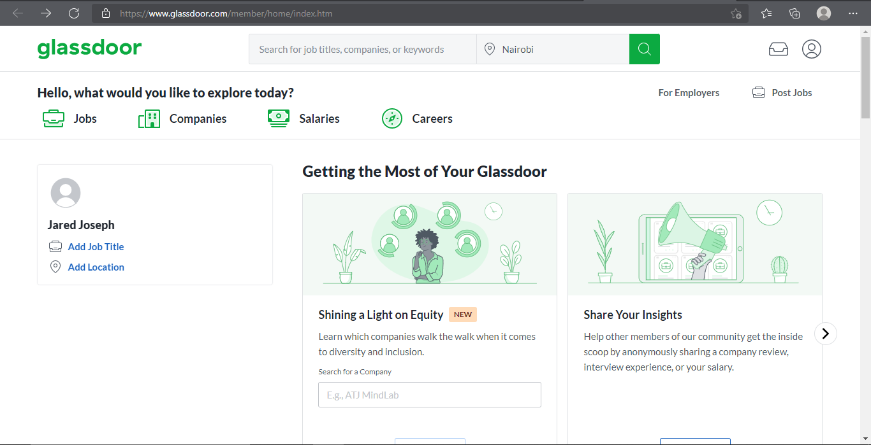

Figure 2.1 Glassdoor

### 2.3.2 Flexjobs

Frustrated by the difficulty in finding legitimate, flexible, work-from-home opportunities, FlexJobs was created by Sara Sutton in 2007. Since its founding, it has become the largest site for hand-screened remote jobs, with nearly 30,000 active listings from almost 6,000 companies across the globe. FlexJobs’s clear dedication to and specialization in remote opportunities made it the obvious choice for the best website for finding remote jobs. ([www.flexjobs.com](http://www.flexjobs.com)). The disadvantage to this was when it comes time to have a review or check-in with your supervisor, working remotely can cause challenges in how you present your achievements. Doing so can be important when you’re asking for a raise or vying for a promotion.

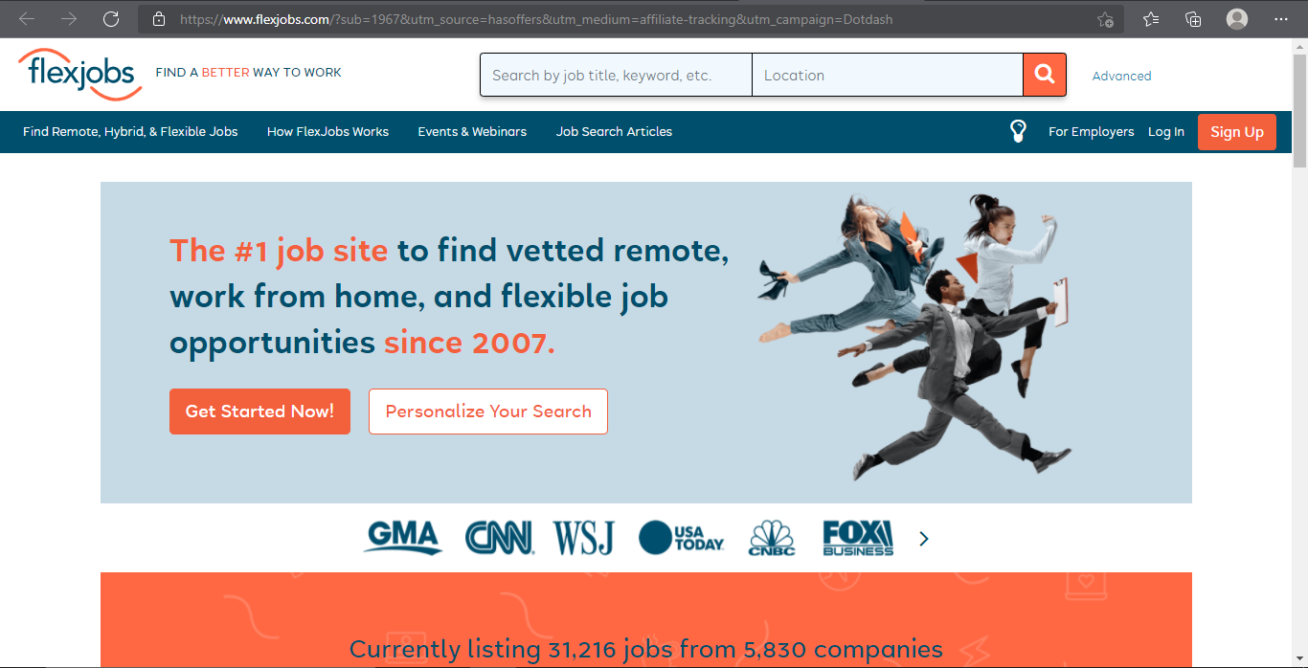

Figure 2.2 Flexjobs

### 2.3.3 Ladders

Known as “the home of $100K careers,” Ladders was founded in 2003 and focuses on providing vetted job listings for positions that pay at least $100,000 per year. Ladders provide job listings for dozens of sectors, including finance, software engineering, digital marketing, human resources, data science, and industrial engineering for major firms such as Morgan Stanley, Google, and Cigna. Upon signing up for Ladders, you’ll be prompted to list the job titles you’re most interested in. Your Jobs tab on Ladders will then automatically present you with job listings that match those titles. Some listings are free to apply to, but others require a paid subscription to the platform. ([www.theladders.com](http://www.theladders.com)). The main disadvantage of this is the Ladders caters toward individuals who can command a $100,000+ salary. Most of the optimum services are only available if you purchase a subscription to the premium plan, though the Ladders features a free basic service as well. The site itself isn't as easy to navigate as other comparable sites we evaluated. Filtering options are slim, and initiating job alerts is a little on the confusing side.

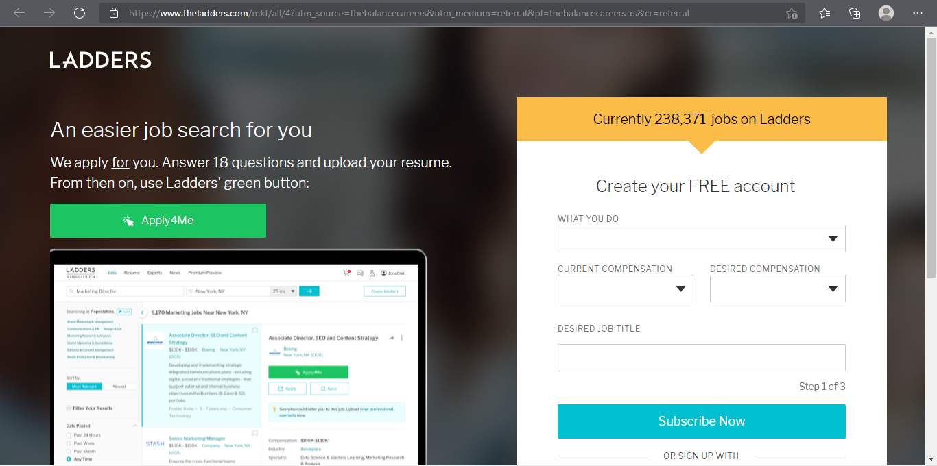

Figure 2.3 Ladders 2.3.4 Conceptual Framework

This is a diagram that aims to explain with ease how the system will work.

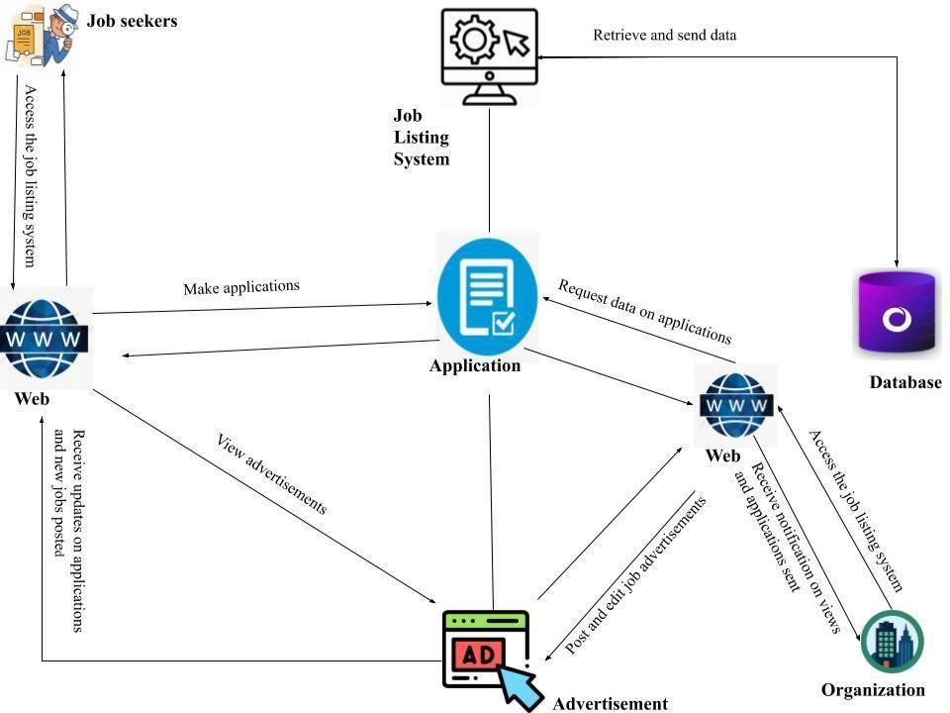

Figure 2.4 Conceptual Framework

### 2.3.5 Class Diagram

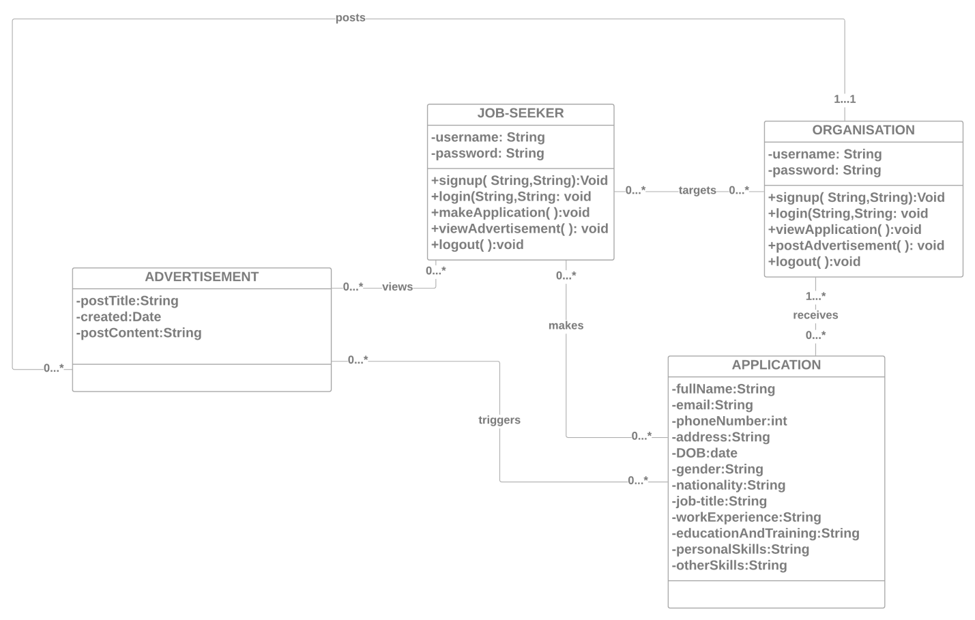

Figure 2.5 Class Diagram